

KLS GOGTE INSTITUTE OF TECHNOLOGY, BELAGAVI

Skill Labs

Schedule of Skill labs offered at KLSGIT
Sl No | Department | Start date | End date | Title of Skill lab
1 | ISE | 30-12-2024 | 03-01-2024 | Elevating Object Oriented Programming Skills

Skill lab (Detailed schedule)
Sl No | Department | Title of Skill lab | Semester & Division | Venue | Dates | Faculty name | Phone No | Email id
1 | ISE | Elevating Object Oriented Programming Skills | 5th sem  A | Lab No. 3, 6 | 30-12-2024  to  03-01-2024 | Dr. Kiran K. Tangod  Dr. Padma Dandannavar  Prof. Anusha Chogund  Prof. Shrivatsa D. Perur | 9448545393  9886230332  9845306014  9845371193 | kirankt@git.edu  padmad@git.edu  apcogund@git.edu  sdperur@git.edu

Skill Lab
ON
Elevating Object Oriented Programming Skills

For 3rd Year Students

KLS GOGTE INSTITUTE OF TECHNOLOGY, BELAGAVI
Department of Information Science and Engineering
Overview:


This Skill Lab is designed to introduce students to the fundamentals of object oriented programming and to develop hands-on skills in problem-solving, algorithmic thinking and object oriented programming. Through practical exercises, students will gain proficiency in the syntax and structure while applying programming concepts to real-world scenarios.
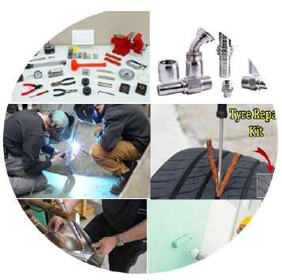

Mode of Conduction of each Module:
Theory: 02 Hours
Demo: 01 Hours Lab Sessions: 03 Hours
Total duration: 06 Hour Certification exam: 03 Hours

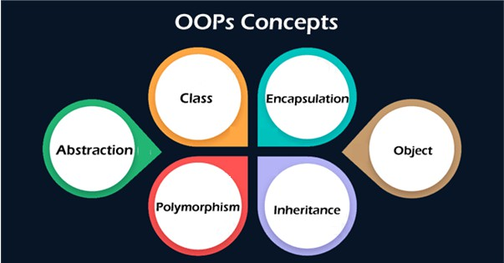

Module 1: Introduction to OOP and Basics

Overview of Object-Oriented Programming

Key Principles

Basic Syntax and Structure

Functions and Scope
Module 3: Advanced Class Features
- Operator Overloading
- Function Overloading
- Overloading Arithmetic and Relational Operators
- Overloading Unary Operators
- Function Templates
- Default Arguments
- Function Templates
- Default Arguments

Module 2: Classes and Objects

Defining Classes & Creating Objects

Class members

Access Specifiers

Constructor and Destructor

Static Member Variables and Functions

Terms and Conditions
- Only students who have paid a skill lab fee to the institution are eligible for the training.
- The students must maintain 90% attendance for obtaining the skill lab certificate.
- Students must attend training as per scheduled time

Friend Functions and Friend Classes
Module 4: Inheritance and Polymorphism
- Types of Inheritance
- The 'protected' Keyword
- Constructor and Destructor Calls in Inheritance
- Function Overriding and Virtual Functions
- Pure Virtual Functions and Abstract Classes

.

.
.
.

Acceptance
In order to accept and start the training program, students are required to register with the respective department. Details to be provided by the student to the department include: Name, USN, UID, Mobile No, Email id:

Coordinators:

Outcomes
Name: Prof. Anusha Chogund
Phone: 9845306014
E-mail: apcogund@git.edu

Name: Prof. Shrivatsa D. Perur
Phone: 9845371193
E-mail: sdperur@git.edu

Name: Dr. Kiran K. Tangod
Phone: 9448545393
E-mail: kirankt@git.edu

Name: Dr. Padma Dandannavar
Phone: 9886230332
E-mail: padmad@git.edu

The OOP Skill Lab equips students with essential programming skills, enhancing problem- solving, and promoting efficient software design. Students gain hands-on experience in real-world coding, mastering core OOP concepts like encapsulation and inheritance. This lab prepares them for advanced studies, careers in software development, and learning other languages by building a solid foundation in object-oriented principles.

.

Students will be able to take up positions like Business Intelligence Analyst, Data Analyst, Power BI Developer post the completion of course.

